
ASSIGNMENT 8: BASIC SQL QUERIES AND AGGREGATE FUNCTIONS
DATABASE MANAGEMENT SYSTEM
ALLIANCE UNIVERSITY
Department of Computer Applications
SUBMITTED BY: RUPESH RL
REGISTER NO: 2511021240035
COURSE: BCA
YEAR: 2ND YEAR
PROJECT NAME: Courier and Parcel Delivery Management System

1. Aim
To write basic SQL queries on the courier database using WHERE, ORDER BY, GROUP BY, HAVING and the aggregate functions COUNT(), SUM(), AVG(), MIN() and MAX(), and to understand their output. The data used is the sample data from Assignment 7.

2. Quick Notes on the Clauses
Clause / function | Use
WHERE | Selects only the rows that satisfy a condition, before any grouping.
ORDER BY | Sorts the result. ASC is ascending (default) and DESC is descending.
GROUP BY | Puts rows with the same value in a column into one group, so that an aggregate function can work on each group.
HAVING | Filters the groups after GROUP BY. WHERE cannot use aggregate functions, HAVING can.
COUNT() | Number of rows. COUNT(DISTINCT col) counts different values.
SUM(), AVG() | Total and average of a numeric column.
MIN(), MAX() | Smallest and largest value of a column.

3. Filtering Records Using WHERE

Query 1: Parcels booked at Bengaluru Central Branch
BookingBranchID 1 is Bengaluru Central Branch. WHERE keeps only the parcels booked there.
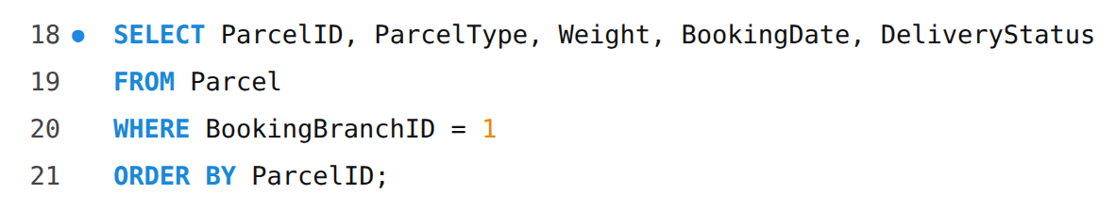
Output:
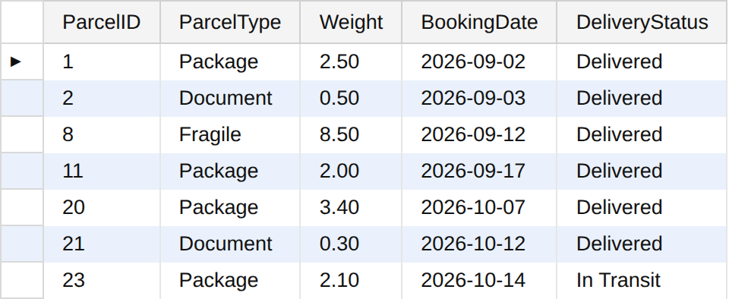
The branch has booked 7 parcels.

Query 2: Heavy parcels of type Package or Fragile
Two conditions are joined with AND, so both must be true. IN checks a value against a list.
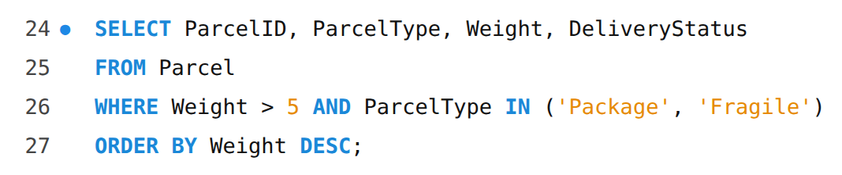
Output:
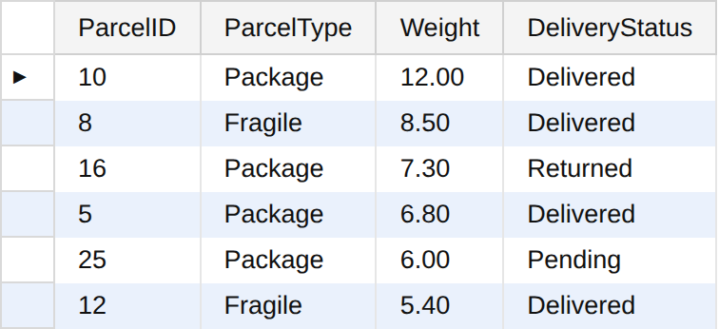
6 parcels are heavier than 5 kg and are not documents.

Query 3: Customers from Bengaluru or Chennai
OR gives the rows that satisfy at least one of the two conditions.
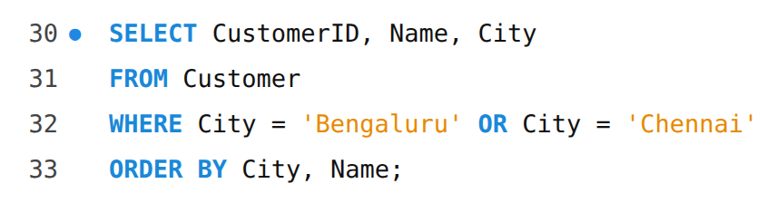
Output:
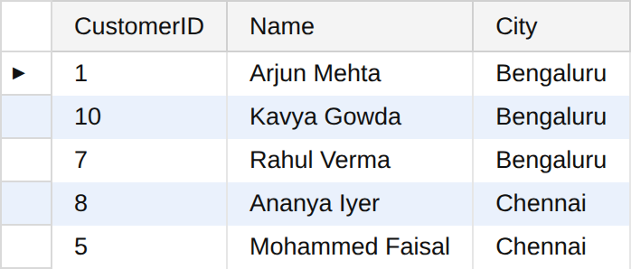

Query 4: Customers with a Gmail address
LIKE is used for pattern matching. The % sign stands for any number of characters, so this finds every email that ends with @gmail.com.
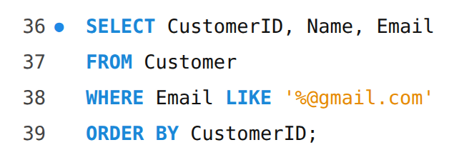
Output:
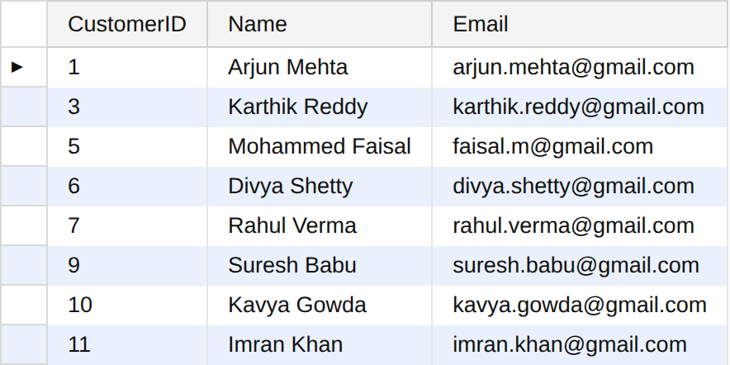

Query 5: Parcels booked between 10 and 20 September 2026
BETWEEN includes both end dates.
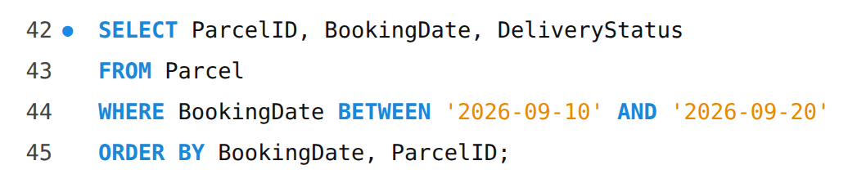
Output:
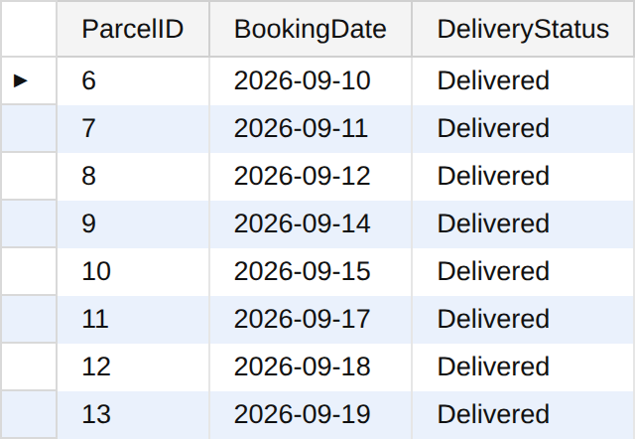

Query 6: Payments that are not paid
<> means not equal to. A NULL PaymentMode means that the customer has not yet chosen how to pay.
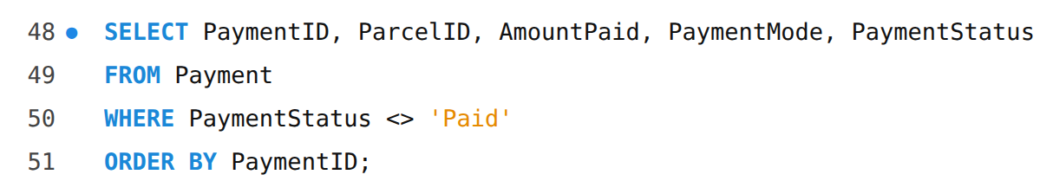
Output:
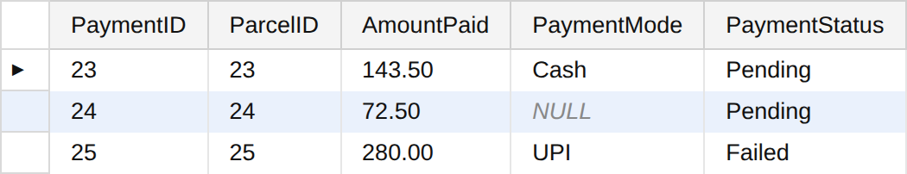
3 payments are still pending or failed.

Query 7: Assignments that have no actual delivery date
NULL means no value, so it cannot be tested with = . IS NULL is used. These are deliveries that are not completed: the failed first attempt of parcel 15, the returned parcel 16 and parcel 22 which is out for delivery.
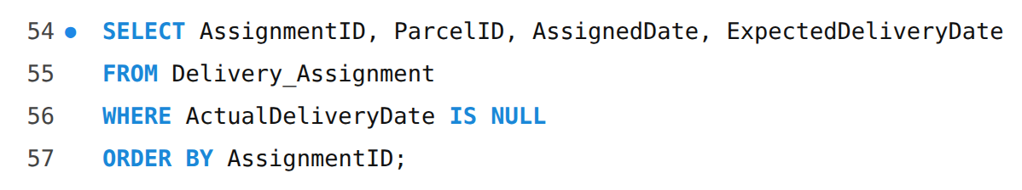
Output:
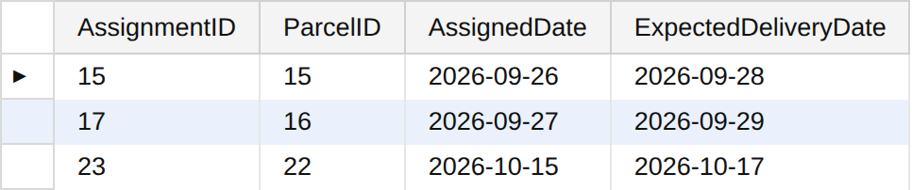

4. Sorting Records Using ORDER BY

Query 8: Five heaviest parcels
DESC sorts from the largest to the smallest. LIMIT 5 shows only the first five rows. ParcelID is the second sort column, used only when two weights are equal.
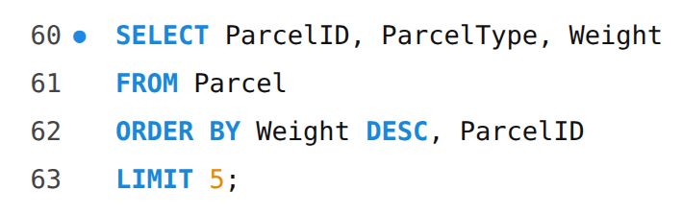
Output:
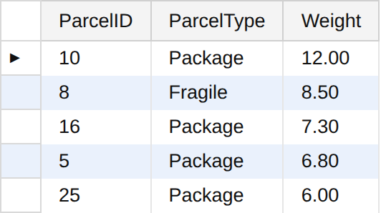

Query 9: Employees sorted by branch and name
Sorting is done on two columns. First by branch, and inside each branch by name.
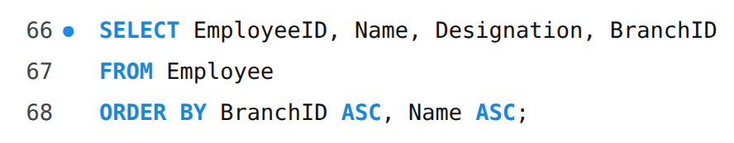
Output:
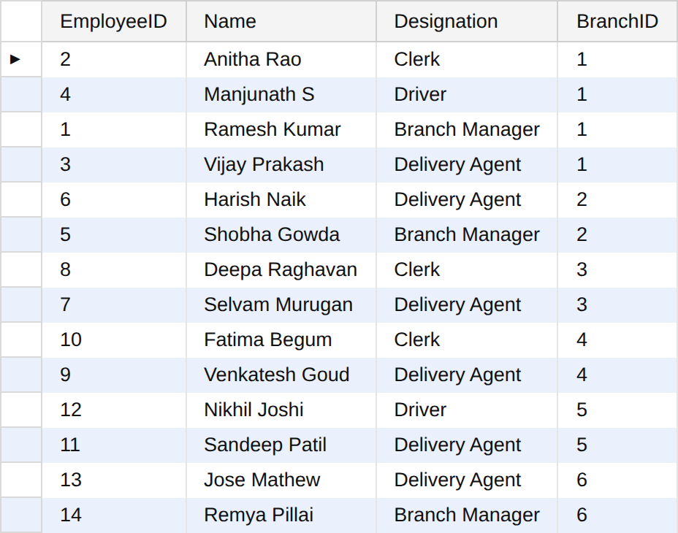

5. Aggregate Functions

Query 10: COUNT of parcels, senders and receivers
COUNT(*) counts all rows. COUNT(DISTINCT ...) counts different values only, so a customer who booked 3 parcels is counted once.
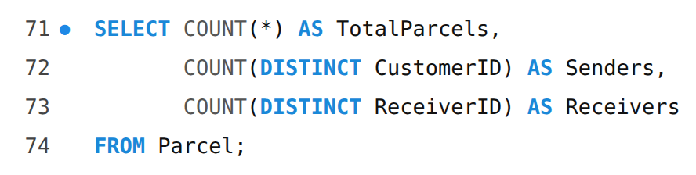
Output:
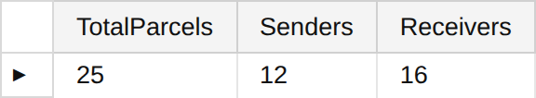

Query 11: SUM, AVG, MIN and MAX of parcel weight
All four functions work on the Weight column of all 25 parcels. ROUND(..., 2) keeps the average to two decimal places.
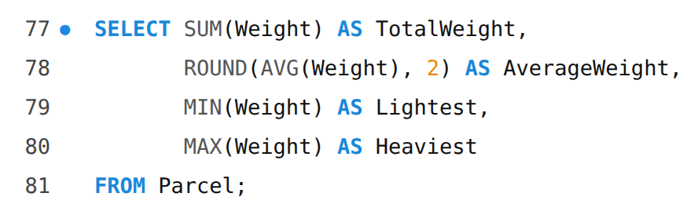
Output:
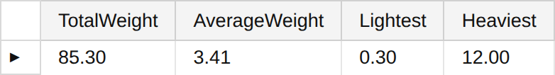

Query 12: Summary of the paid payments
WHERE is used first to take only the paid payments, and then the aggregate functions work on those rows.
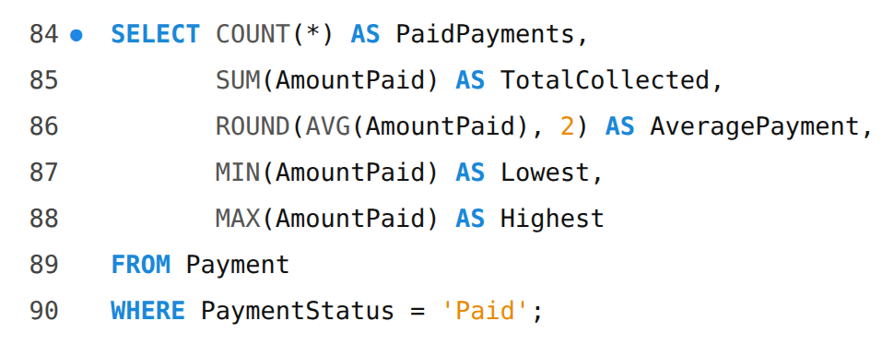
Output:
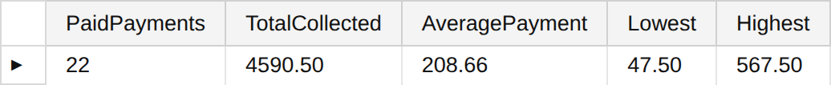

6. Grouping Records Using GROUP BY

Query 13: Number of parcels in each delivery status
One row is produced for each status, with the number of parcels in that group.
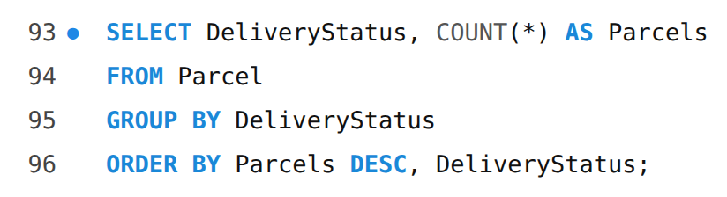
Output:
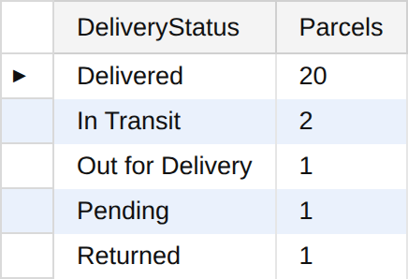

Query 14: All five aggregate functions for each parcel type
The aggregate functions are applied separately to each type: Document, Fragile and Package.
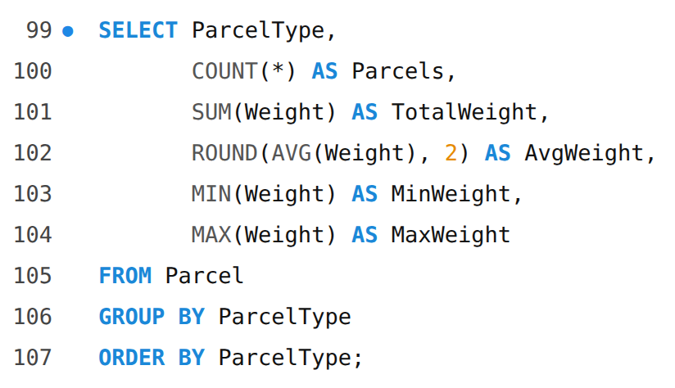
Output:
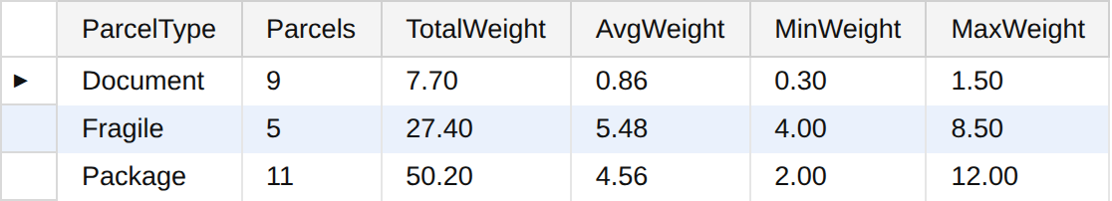

Query 15: Money collected by each payment mode
Only paid payments are taken (WHERE), and then they are grouped by Cash, Card and UPI.
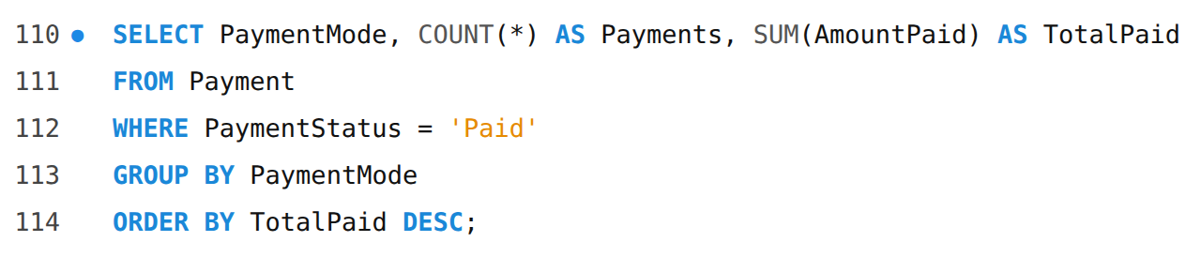
Output:
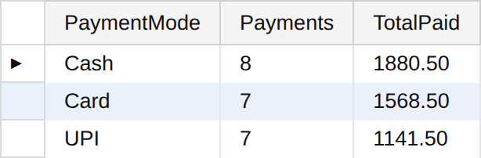

Query 16: Parcels booked at each branch
The branch is shown by its ID here. The branch name will be shown using a join in Assignment 9.
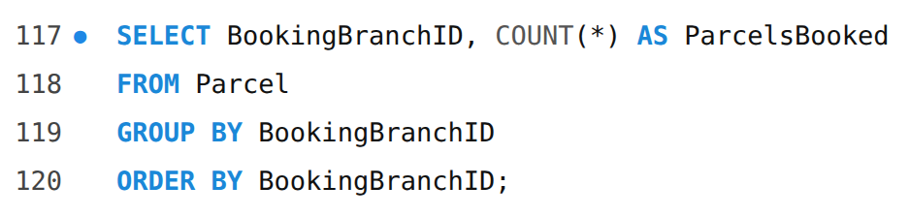
Output:
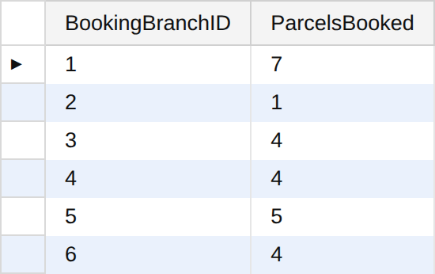

Query 17: Employees in each designation
Shows how many people work in each role.
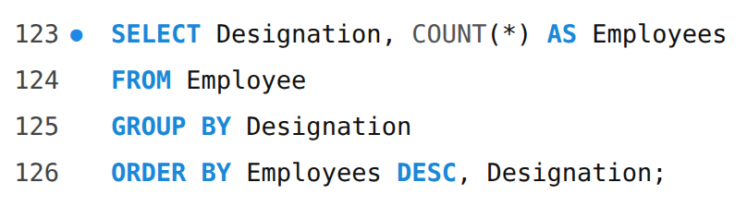
Output:
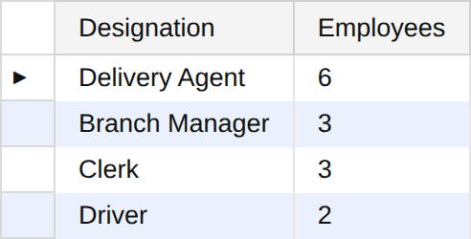

7. Filtering Groups Using HAVING

Query 18: Customers who booked more than 2 parcels
WHERE cannot be used with COUNT(*), because the count is known only after grouping. HAVING filters the groups. Out of 12 customers, only the ones with 3 or more parcels remain.
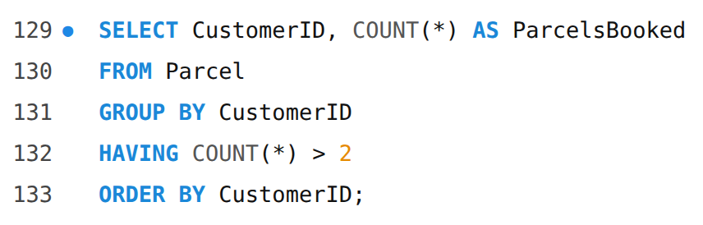
Output:
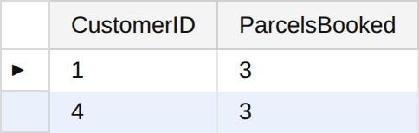

Query 19: Parcel types whose average weight is more than 3 kg
Groups are formed by type, and the groups whose average weight is 3 kg or less are removed.
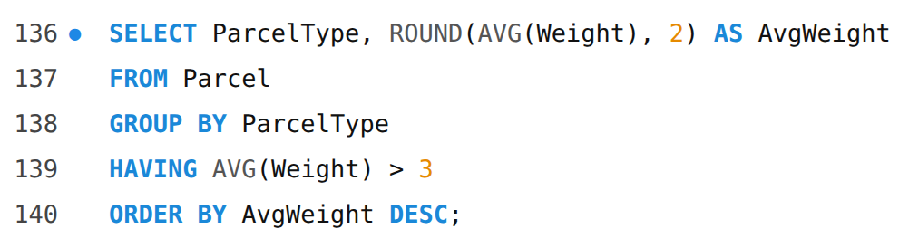
Output:
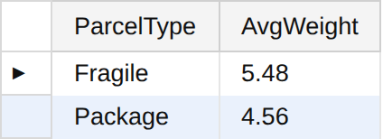

Query 20: WHERE, GROUP BY, HAVING and ORDER BY together
The order in which the clauses work is: WHERE removes the rows that are not delivered, GROUP BY makes groups, HAVING removes small groups, and ORDER BY sorts what is left.
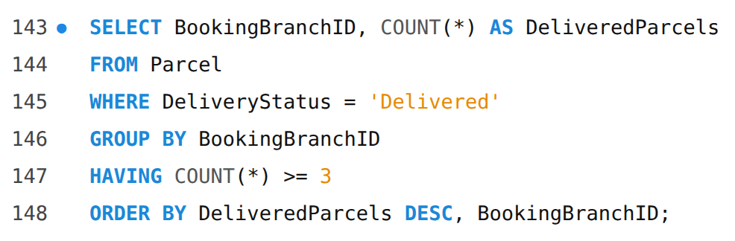
Output:
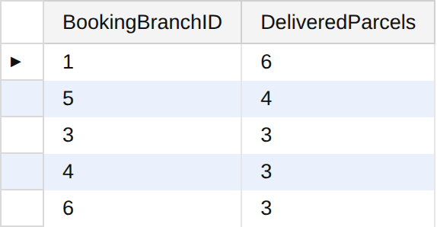

8. Changing Data (INSERT, UPDATE, DELETE)
To show INSERT, UPDATE and DELETE without spoiling the sample data, I did these changes inside a transaction and cancelled them with ROLLBACK at the end.
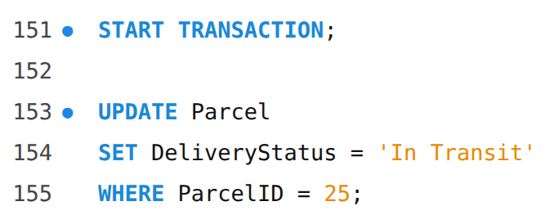
Output:
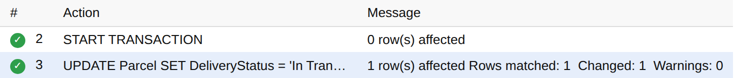
Output:
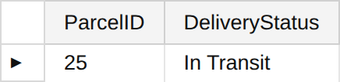
The status of parcel 25 changed from Pending to In Transit.
Output:
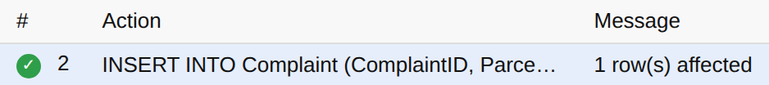
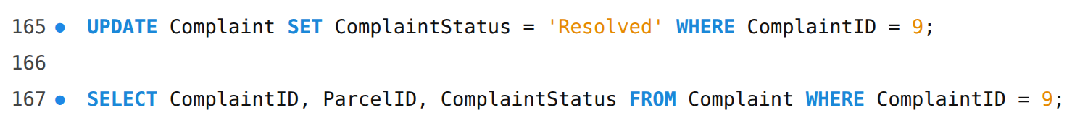
Output:
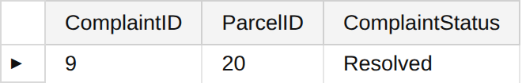
Output:
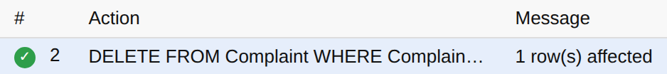
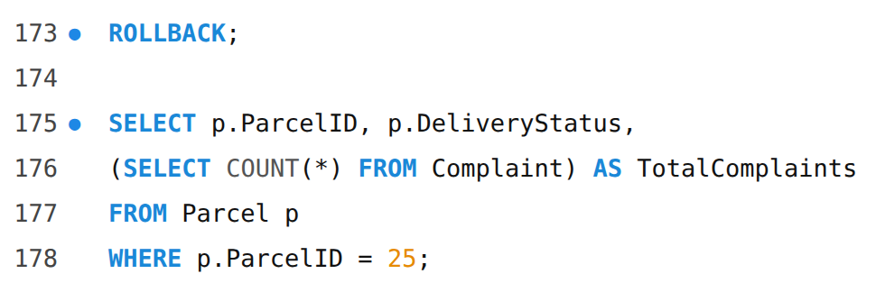
Output:
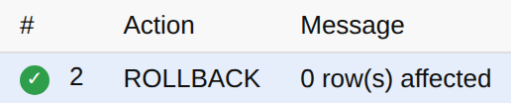
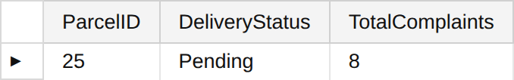
After ROLLBACK, parcel 25 is Pending again and there are 8 complaints as before, so the sample data is back to its original state.

9. Result
Twenty queries were written using WHERE, ORDER BY, GROUP BY, HAVING and the aggregate functions, and their outputs were checked. INSERT, UPDATE and DELETE were also tried and rolled back.

10. Conclusion
These queries show how SQL can pick, sort, group and total the data of the courier system. WHERE picks the rows, ORDER BY sorts them, GROUP BY makes groups, the aggregate functions give counts, totals and averages for each group, and HAVING removes the groups that do not match a condition. The next assignment combines tables using joins and subqueries.

